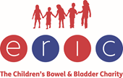
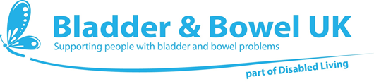

School Toilet Charter
Access to clean, appropriately stocked toilets whenever the need arises, is a fundamental human right and necessary for good health and wellbeing. This reflects the United Nations Convention on the Rights of the Child (UNCRC), which upholds all children’s rights to their best interests being of primary consideration, to healthy development, to participation in decision making, to privacy, to special care and support if they have a disability and to education.
This School Toilet Charter is designed to assist schools in meeting these rights.
All schools should provide:
- Unrestricted access to a toilet, whenever the need arises. This means no school should have a policy of not allowing learners to use the toilet during lesson times.

- Adequate numbers of facilities for all, which ensure privacy.

- Dedicated gender-neutral toilets, or female and male toilet cubicles, properly equipped, for users with additional needs. This includes provision of appropriate waste bins and integral washbasins.

- Properly designed toilet and washroom facilities, suitable for the range of anticipated users, with adequate lighting, ventilation, fixtures and fittings.

- Hot water, ideally from mixer taps, with adequate provision of soap and hand drying facilities.

- Toilet tissue dispensers provided at a convenient height, replenished as needed throughout the day.

- An effective toilet cleaning/inspection regime to ensure adequate standards of hygiene, behaviour and cleanliness, throughout hours of usage.

- A published school toilet management policy approved by school governors and learners and communicated to all learners, parents/carers and staff.

- Open access to water throughout the day for all learners, unless inappropriate (e.g. in science labs, computer suites etc)

- A child friendly comments/complaints/suggestions procedure, for learners, parents/carers and staff to communicate toilet concerns or grievances to the head teacher and/or school governors.

Copyright: Bladder & Bowel UK and ERIC, The Children’s Bowel & Bladder Charity (2022)

